Big Mountain Resort installed an additional chair lift in the skiing resort, and it will raise the operating cost of the season by $1.5 million. The hypothesis was to either increase ticket prices via a different pricing strategy, or reduce operation costs, in order to cover the cost of installing and maintaining another chair lift.

After cleaning the data of all the skiing resorts across the US, I chose two different models to fit the data, linear and random forest, and compared the results. Below are the bar graphs of the 8 most important features according to both models, and these 8 features explain over 80% of the variance observed.

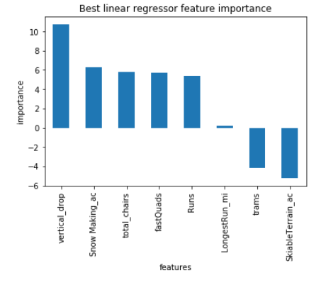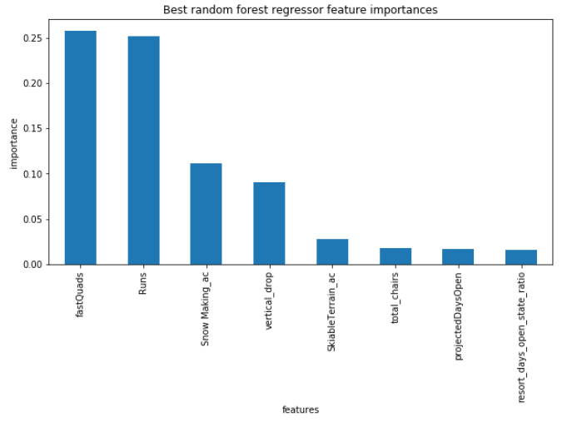

First observation from the 2 bar graphs is that the total number of chairs is among the most important features that positively correlate to the ticket price in both models, which indicate that installing an extra chair was a good business decision.

The two models agree on 4 of the 5 most important features, they are the highest vertical drop, snow making capacity, number of runs, and the number of fast quad chairs. The following are 4 histograms displaying where Big Mountain Resort lies compared to other resorts.

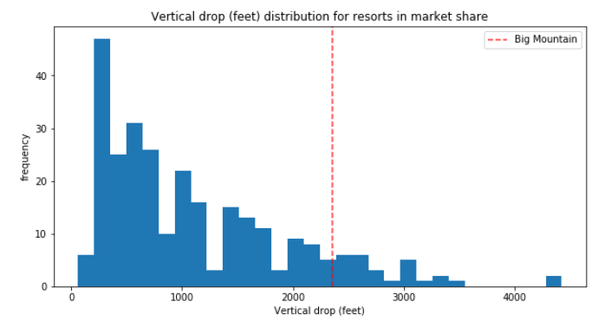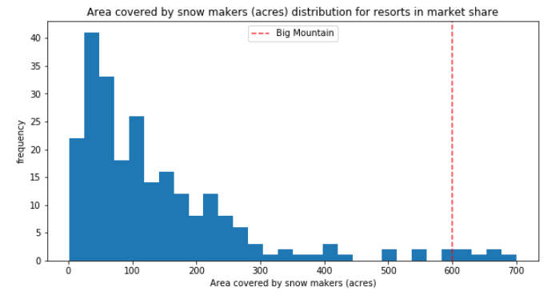

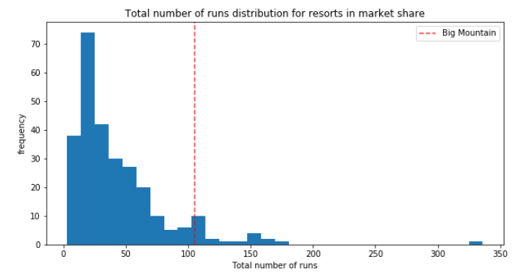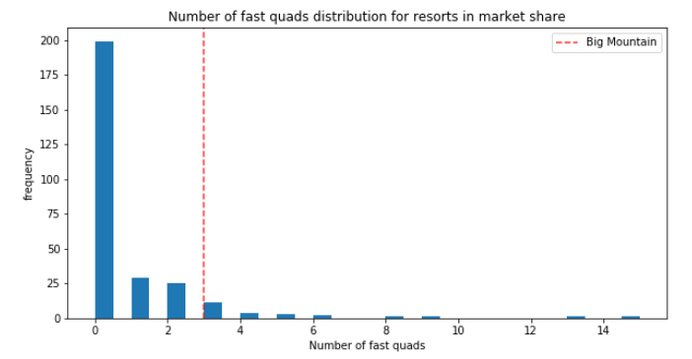

From the above histograms, it is apparent that Big Mountain Resort is well above the market average on all of the 4 most important features. The following is Big Mountain Resort’s ticket price compared to other resorts.

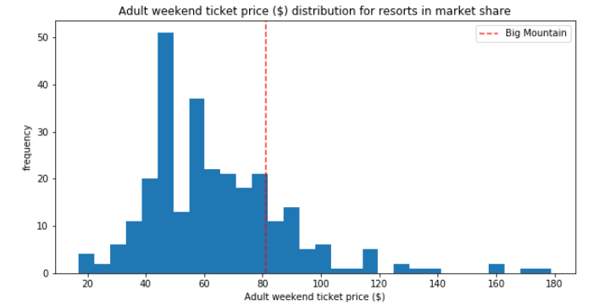

Upon first inspection, at $81 per ticket, Big Mountain Resort’s ticket price is also above the market average, but it doesn’t seem like it is at the same level as all of its important features.

The random forest regression model was found to be slightly more accurate than the linear regression model (lower cross validation MAE by about $1), so it was used for final prediction. After assessing all of Big Mountain Resort’s feature, the model suggested ticket price of $94.

Assuming current number of visitors of 350,000 per season and each visitor purchases 5 tickets, the $13 increase in ticket price will translate to more than $22 million increase in revenue, which will easily cover the projected operating cost increase of $1.5 million.